Analyzing City Hotel Bookings in Portugal (2016)

Final Report
Introduction

Hotels operate on a constant flow of guests, but booking cancellations create a persistent challenge, impacting potential revenue and room availability optimization. This project explores a detailed dataset to understand the factors influencing booking outcomes, examining customer behavior in both canceled and confirmed bookings.

Business Impact
The analysis of City Hotel Bookings dataset could help decision makers to:
- Identify guests’ bookings preferences: By understanding the trends in bookings made, through analyzing the date of booking creation, the arrival volume over the months, the preferred days to stay, type of guest and which distribution channel is preferred by the guests and which market segment they belong.
- Identify canceled booking chrematistics: Understanding the main factors that are resulting in high cancelation rates, by analyzing the lead time, ADR, market segments, deposit type, distribution channel, cancelation trend over months, and customer type.
- Develop new strategies to reduce cancelation rates and the negative impact on revenue: After arriving to a conclusion, the analysis will provide suggestions to focus and maintain the factors which are generating revenue, adjust cancelation policy, and suggest strategies to revise the factors resulting in cancelation.

Data
File Name: city_hotel_bookings_2016.csv
Description: City Hotel Bookings dataset during 2016 (hotel based in Portugal)
Dataset Details: 38,140 rows and 32 columns
Size: 16mb
Source: Kaggle

Data Analysis & Computation

Data Profiling:
- Get the total number of rows and columns (2640 rows & 35 columns)
- Examine information about the null values and data type of each column using excel.
- Check the total number of null values in each column and get statistics of all columns (numerical and categorical) using python code (output in html), highlighting 2 fundamental logics while query the data:
- Selected data is restricted where hotel = “city hotel” and arrival_date_year = 2016 without specifying booking cancelation status.
- Selected data is restricted where hotel = “city hotel” and arrival_date_year = 2016 and is_canceled = 1 specifying canceled bookings.
Total Bookings: (download the file)
https://drive.google.com/file/d/1v7YFAJy7bWr5SVMeEhcvR8GVK9LgneuF/view?usp=drive_link
Canceled Bookings: (download the file)
https://drive.google.com/file/d/1IZg2eJCfll3_DIL1FQ3xlBoIY7PUnnfG/view?usp=drive_link

Observations:
- 2 out of 32 columns include null values. 2 columns are removed
- Removed from ADR outliers i.e., very high number (5400) and very low numbers (0-18), total of 644 row was removed
Data Analysis:

1- Confirmed vs Canceled Bookings Ratio
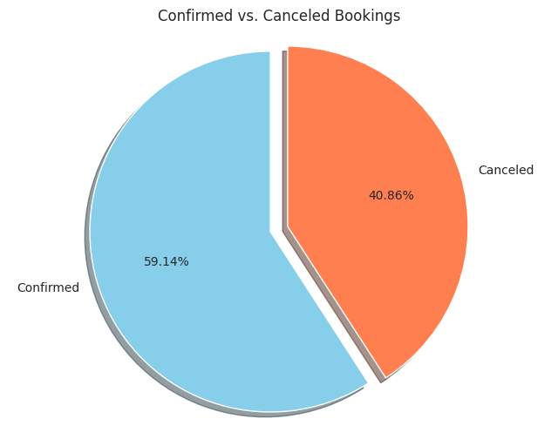
Confirmed bookings are representing 60% from total bookings, where as canceled bookings are representing 40%. This can be easily visualized using a pie chart through Python specifically Pandas

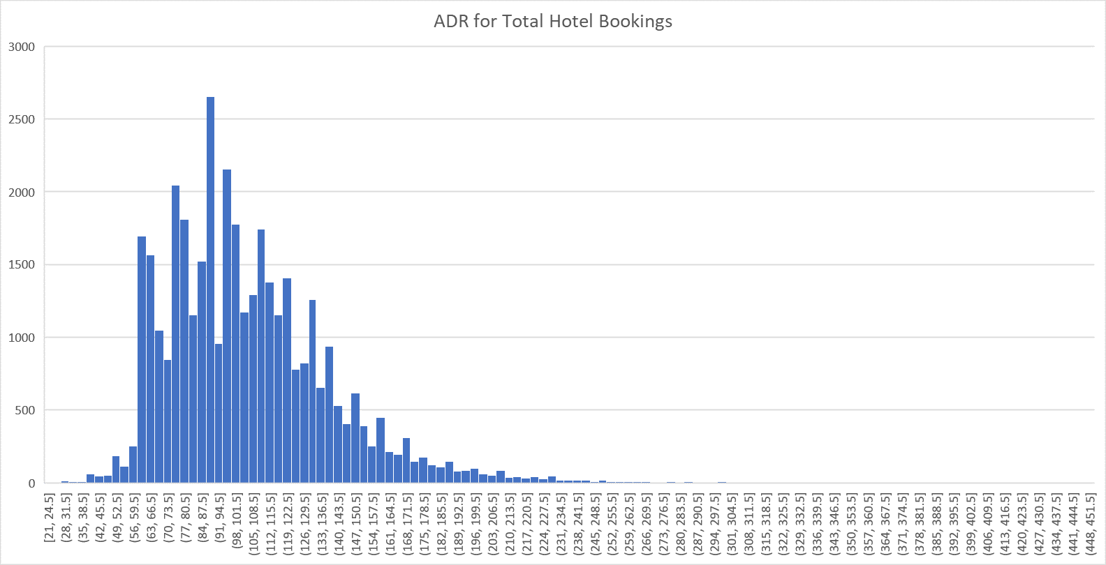

2- ADR Distribution
The ADR is mainly concentrated in the price range between 50 and 86.

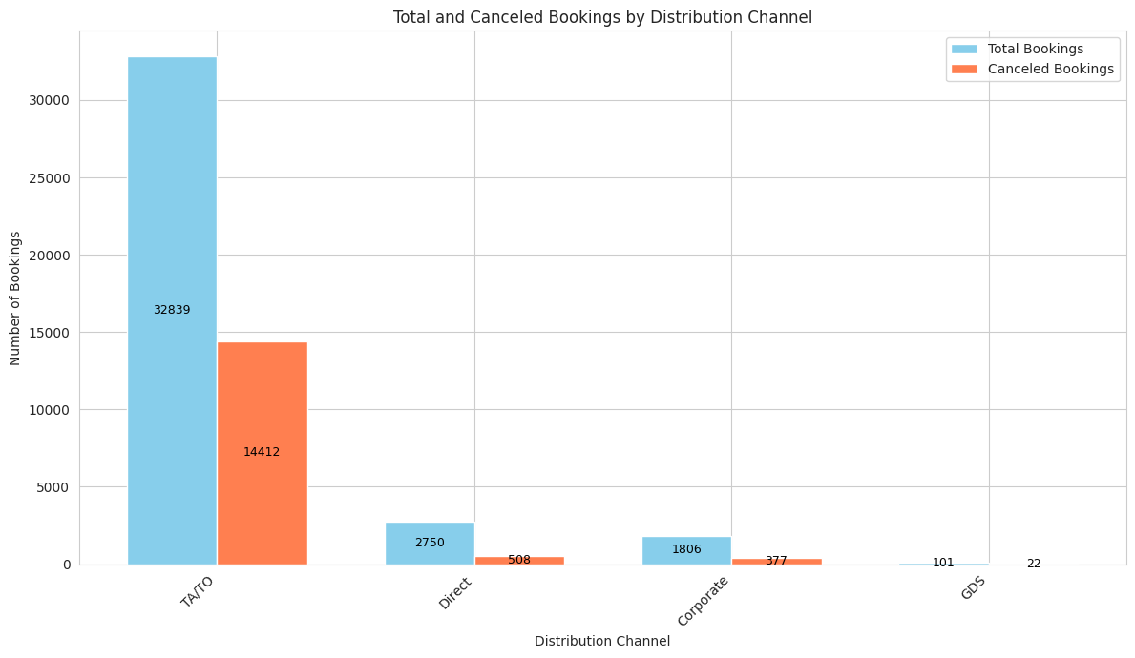
3- Distribution Channel Analysis
Mainly bookings are made through TA/TO with 32,839 bookings with highest number canceled bookings (14,412). This was clear through the barplot that shows the count of each category using python.

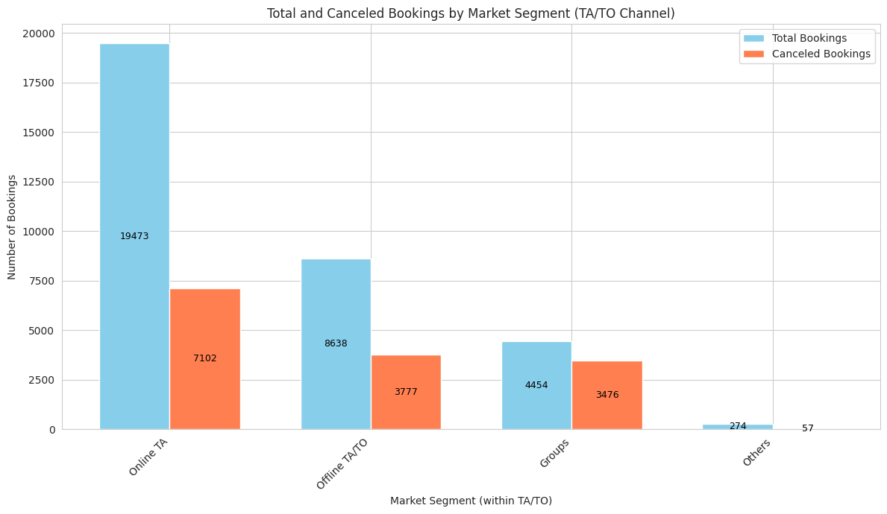
4- Market Segment for Booking made through TA/TO Analysis
Digging deeper in bookings made through TA/TO to target market segment with highest bookings and cancelation, it showed that the Online TA and Offline TA/TO specifically were on the top with bookings and cancelations. Emphasizing that the hotel is depending largely on bookings made through online websites and travel agents or tour operators, bookings made through direct channels are minimal.

5- Customer Type Analysis for Bookings made through TA/TO
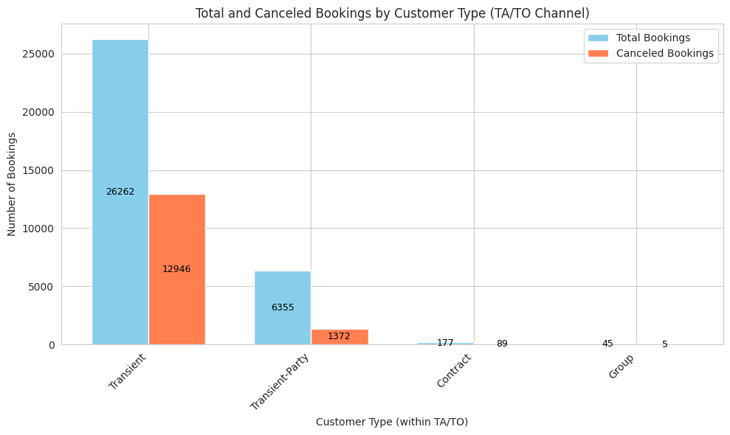
The bar plot is showing that Hotel’s customer type is the “Transient” with less focus on contracted or groups business.

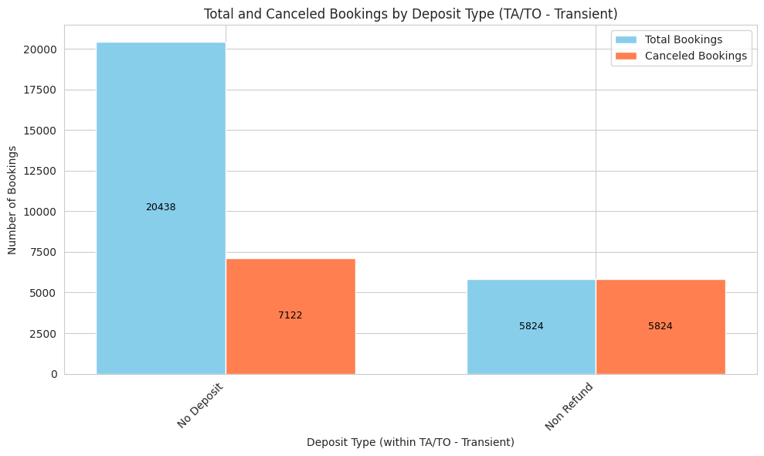

6- Deposit Type for Transient Customer Analysis

The bar plot is showing that bookings made through TA/TO by Transient Customers are mainly made with no deposits with the highest cancelation bookings, indicating revenue loss and non-efficient rooms availability optimization.

Conclusion & Future Work

Conclusion:
The analysis conducted has provided clear focus areas:
- High reliance on Online TA/TO: The hotel is heavily dependent on bookings through online travel agencies and tour operators, which often come with a higher risk of cancellation due to ease of booking and flexible cancellation policies.
- No-deposit bookings: The prevalence of no-deposit bookings, particularly through online channels, contributes to increased cancellations as guests face minimal financial consequences for canceling.
- Last-minute bookings: A significant portion of both confirmed and canceled bookings are made last minute, indicating a need for targeted strategies to manage these bookings effectively.
- Limited direct bookings: Direct bookings through the hotel's website or reservation channels are minimal, highlighting a missed opportunity to reduce reliance on third-party channels and potentially improve cancellation rates.
- Seasonality: Booking volume peaks during the summer months, indicating a need for strategies to manage demand and potentially mitigate cancellations during this high-demand period.

Suggestions:

- Revise Cancellation Policies: Implement stricter cancellation policies, including deposit requirements and cancellation fees, particularly for last-minute bookings and those made through online TA/TO channels. Consider tiered cancellation policies based on lead time and booking value.
- Promote Direct Bookings: Develop strategies to incentivize direct bookings, such as offering exclusive discounts, loyalty programs, or value-added services to guests who book directly. This can help reduce reliance on TA/TO channels and potentially improve cancellation rates.
- Optimize Revenue Management: Implement revenue management strategies to manage demand and pricing effectively, especially during peak season. This could include dynamic pricing, overbooking strategies, and targeted promotions to maximize occupancy and revenue.
- Enhance Guest Communication: Improve communication with guests throughout the booking process, including pre-arrival reminders, confirmation emails, and clear cancellation policies. This can help reduce cancellations due to misunderstandings or changes in plans.
- Monitor and Analyze: Continuously monitor cancellation trends and analyze the effectiveness of implemented strategies. This data-driven approach will enable the hotel to adapt and refine its cancellation management strategies over time.

